Benny & Bugs Random Provisions

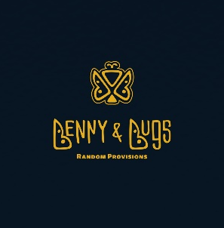

Zack Gadberry of UAV Cheese has been known to show his love through the food he makes. While you may already know his heart and soul go into each piece of cheese he makes for the markets, now you'll have the opportunity to try some new culinary creations from Zack. Allow us to introduce Benny & Bugs Random Provisions. Named after the nicknames of our beloved children, Lily & Ben, this new venture will allow us to share more of our favorite foods, sauces, dishes, and more with you at the Matthews Community Farmers Market every Saturday. B&B will feature staple items that will be at the market available for purchase weekly, as well as 'random' items that will rotate on a weekly basis so there will always be something new and fresh to check out. We can't wait to see you soon.

Staple List
Bolognese Kits
Best Hummus Ever
Chicken Pie
Take and Bake Chocolate Chip Cookies
Pimento

Random List
German Goetta Sausage
New England Clam Chowder
Random Hummus:Spicy Zhoug
Oat Milk Ranch
Chimichurri Sauce

For product descriptions and to pre-order.

https://www.bennyandbugs.com/

Instagram: benny_and_bugs_

